Inflammation at cellular level:
https://www.bing.com/videos/search?q=inflammation+cellular+response&&view=detail&mid=7EACD9F43F0EB210BA4F7EACD9F43F0EB210BA4F&&FORM=VDRVRV
https://www.bing.com/videos/search?q=inflammation+cellular+response&&view=detail&mid=6428FA205BE9ABA535616428FA205BE9ABA53561&rvsmid=7EACD9F43F0EB210BA4F7EACD9F43F0EB210BA4F&FORM=VDRVRV
Inflammation:
https://www.bing.com/videos/search?q=inflammation+cellular+response&&view=detail&mid=5D1F4C39C070C7D16D625D1F4C39C070C7D16D62&&FORM=VDRVRV
Bursa

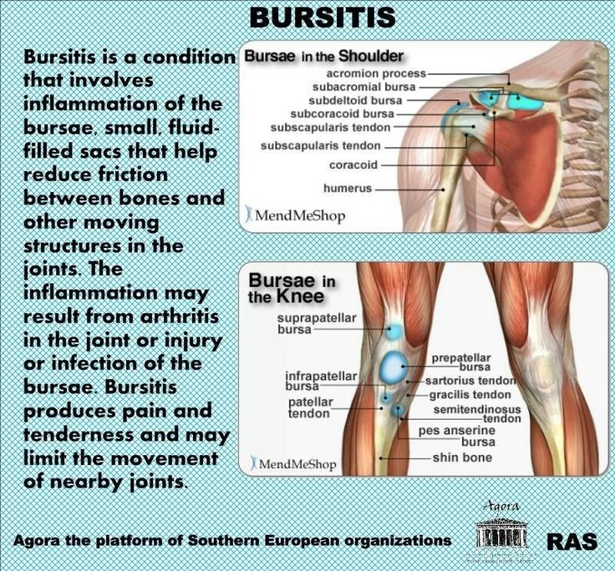
https://www.bing.com/images/search?view=detailV2&ccid=ST1Lq1ra&id=973249515E57811DC81BEF7AC5EC8834E3CA983C&thid=OIP.ST1Lq1rato4Wm7_wGfc4qAHaG4&mediaurl=http%3a%2f%2fmedia-cache-ec0.pinimg.com%2f736x%2f5e%2f55%2f92%2f5e5592cb23e739a95602fa8e6ff4e92e.jpg&exph=684&expw=736&q=bursitis&simid=608017976000382813&selectedIndex=1&ajaxhist=0
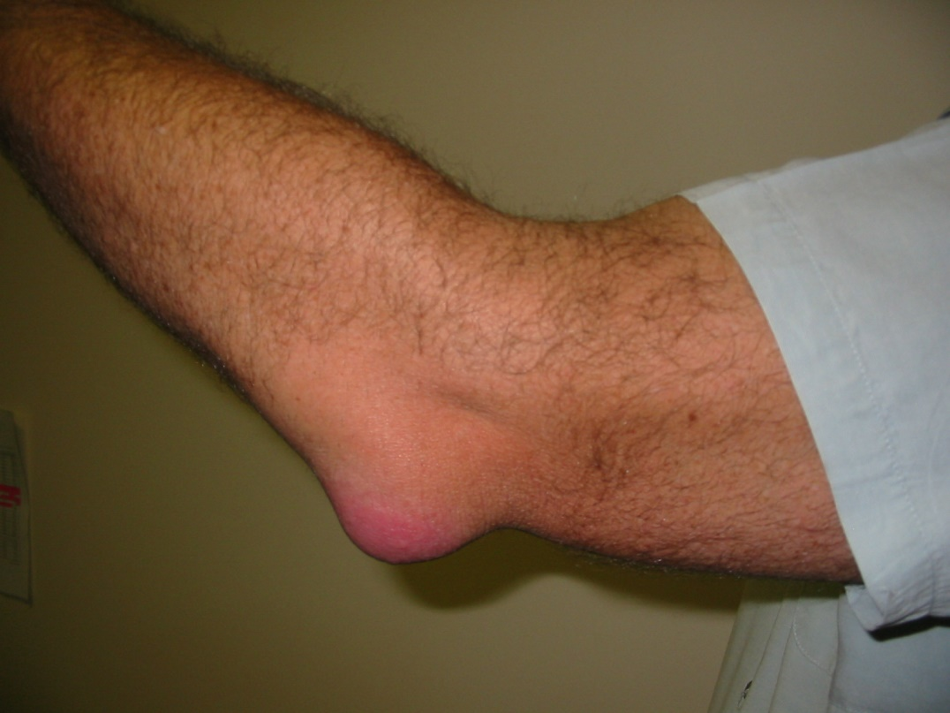
https://www.bing.com/images/search?view=detailV2&ccid=k2hWXorU&id=5D5ACD2DDF079E5C8889CDDA8FFAA12B3EF737BD&thid=OIP.k2hWXorUVYtWUfytWo9bkgHaFj&mediaurl=http%3a%2f%2fdrugline.org%2fimg%2fterm%2felbow-bursitis-4943_2.JPG&exph=1200&expw=1600&q=bursitis&simid=608018027522949195&selectedIndex=5&ajaxhist=0

